Bhartiyam International School
Periodic Assessment I (2022-23)
Subject: EVS (SET -2)
Class -III
Date: 11/7/2022 Max. Mark: 20
Name. _________ Roll no. ______ Duration: 1 hr
General Instructions:
1. The question paper contains four sections.
2. All questions are compulsory.
3. Marks for each question are marked along with.
Section - A
I. Tick the correct option: (0.5X8=4) i.Which of the following is not an internal body organ?
a .kidney b.heart c .nose d. lungs
ii. What is the shape of brain ?
a. j-shaped b. cone-shaped c. walnut-shaped d. none of these
iii. How many organs in our body are present in pairs?
a.one b. two c. three d. four
iv. Any practice or custom followed in your family is a __________
a. responsibility b. resemblance c. traditions d. none of these
v. The ____________help in breaking down of food.
a. stomach b. heart c. lungs d. windpipe
vi.___________ is also called festivals of colors.
a.Gurupurab b.Christmas c.Diwali d.Holi
vii. Which of the following organs remove wastes from the body.
a. heart b. liver c. kidney d. brain
viii. Your father’s father is your __________.
a.grandfather b. father c. maternal grandfather d. none of these

II.Define: (1X4=4)
i. External organs-_________________________________________________________

_____________________________________________________________________

ii .Generation-___________________________________________________________

_____________________________________________________________________

iii. Exhalation-___________________________________________________________

_____________________________________________________________________
iv. Custom-_____________________________________________________________

_____________________________________________________________________

Section - B

III. Very Short Answer Type Questions : -
( 2X1=2)
i.If our body needs more oxygen , how will it affect our breathing?

_____________________________________________________________________

_____________________________________________________________________

_____________________________________________________________________

Section – C

III. Short Answer Type Questions : - (3X2=6)

i.What practices does your family follow to keep the surroundings clean?
Or
What work do the different members of your family do?

_____________________________________________________________________

_____________________________________________________________________

_____________________________________________________________________

_____________________________________________________________________

ii. What makes families different ? Give an example ?

_____________________________________________________________________

_____________________________________________________________________

_____________________________________________________________________

_____________________________________________________________________

Section - D

IV. Long answer questions: - (4X1=4)

i. i.Identify the picture and write its function :-
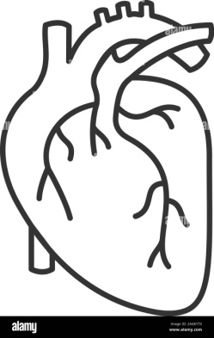
a) b)
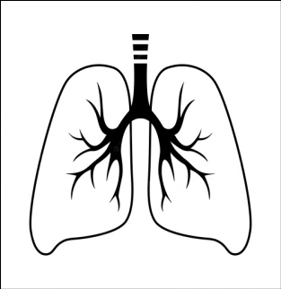

a)Name-_________ b)Name-_________
Shape -_________ Shape-_________
Function-________________ Function-________________
_______________________ _______________________
_______________________ _______________________
Or
How do you show respect to elders in your family?

_____________________________________________________________________

_____________________________________________________________________

_____________________________________________________________________

_____________________________________________________________________

_____________________________________________________________________

